Topic: Low / Zero Carbon Emission Buildings and Communities (12 pt. Leave one line after)

Template for Extended Abstract of COBEE2022 (14 pt. Bold. Capitalize the First Letter of Keywords)

Liangzhu (Leon) Wang¹, Michael Lacasse², and Yan Chen^{3, *} (12 pt. Use first name, middle initial, and last name format)

¹Department of Building, Civil, and Environmental Engineering, Concordia University, Montreal, Quebec, Canada (12 pt.)
²Building Envelope and Materials Research Unit, Construction Research Centre (CONST), National Research Council, Ottawa, Canada (12 pt. leave one empty line after)
³Department of Building Services Engineering, The Hong Kong Polytechnic University, Hong Kong, China (12 pt. leave one empty line after)

*Corresponding email: cobee2022@concordia.ca (12 pt. Leave one empty line after)

Keywords: Maximum five keywords, Capitalize the first word, Separate by a comma (12 pt. Leave one empty line after)

SUMMARY (Times New Roman Bold 12 pt, UPPERCASE, leave a blank line before and after the main level headings)

Prepare an informative summary of up to 150 words for your extended abstract. The summary should provide information on the purpose of the study, methods or procedures, results, discussion, and concluding remarks.

INTRODUCTION

The introduction should present the practical and scientific background for the study or presentation, the hypothesis(es), and a clear statement of the objective(s) of the study/presentation. (Leave one blank line between paragraphs throughout)

This instruction is for the extended abstract. This file can be used as a template by simply replacing the corresponding text with your own. Please submit this extended abstract in PDF file to online submission system (https://www.conftool.pro/cobee2022/) by February 1st, 2022. Please name the file of this extended abstract as EA_ID_v1.pdf, where “ID” is the paper number assigned to you by COBEE2022. The “v1” stands for version 1. For example, a paper file can look like EA_211_v1.pdf.

The length of the extended abstract is three pages, including references, figures, and tables. Please use Letter size format (21.59 cm × 27.94 cm). All margins should be set to 25 mm. Use single-column format. All text should be justified using Times New Roman font with 12 pt size. Leave a blank line between paragraphs and before and after the main level heading. Please use 12 pt UPPERCASE bold font for main headings and 12 pt normal lowercase (The first letter capitalized) bold font for 2nd level headings. Avoid use 3rd level headings. Please do not number the pages.

METHODS

This section should briefly describe the study design, materials, measurement methods, and procedures, and statistical methods. Measurement and statistical methods should be mentioned, but for routine methods, a reference rather than a description of the method is recommended.

RESULTS AND DISCUSSION

Please present results and provide overall comments on the findings and their applicability in other settings or applications.

Tables and illustrations (Times New Roman Bold 12 pt, Lowercase for 2nd level heading)
A table must have a suitable caption above it, and a figure must have a caption below it. Use a three-line table as shown in Table 1. Please insert figures as ‘picture’ (e.g., wmf or jpg), not as ‘objects’ or spreadsheets. Do not extend figures or tables beyond the margins. Please do not shrink the figures too small.
(Leave one blank line before and after tables, figures, and equations)

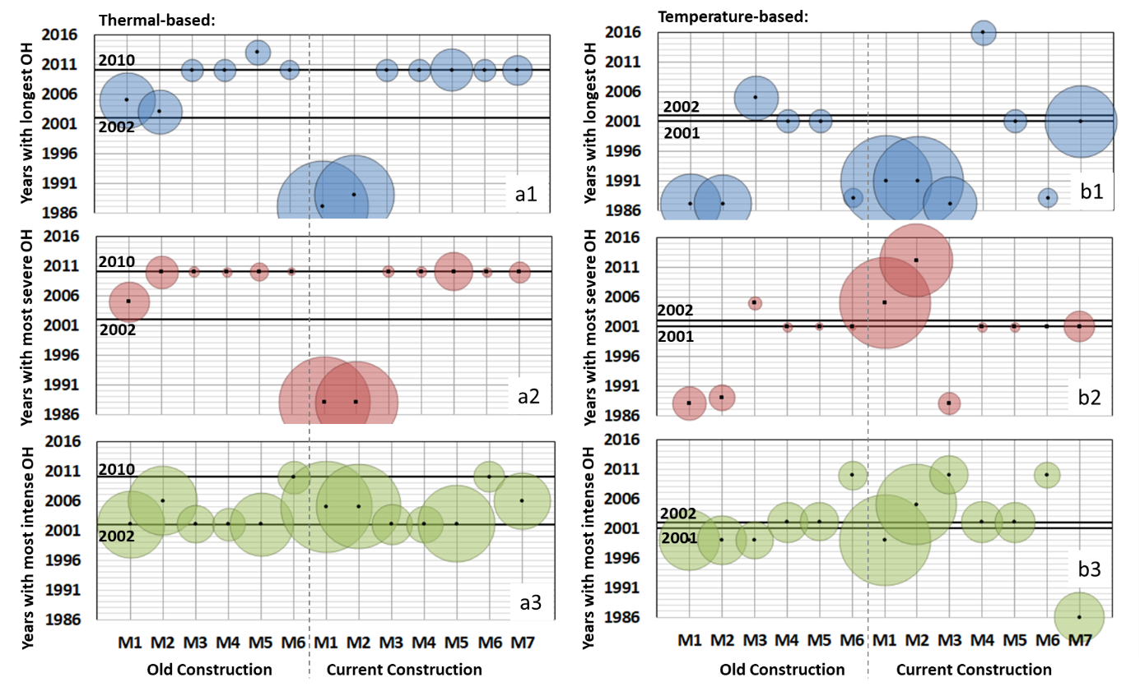
Figure 1. Indoor extreme years and the overheating (OH) magnitude (relative) for the single-detached house with various configurations in Ottawa (Ontario) [1].

Table 1. The unique EHY of each city (Italic table caption) [1].
City | Unique EHY | Extreme heatwave
 |  | Severity (℃∙h) | Intensity (℃)
Ottawa | 2010 | 436.5 | 2.6
Montreal | 2010 | 521.7 | 3.2
Toronto | 2013 | 431.9 | 3.0
Baltimore | 2006 | 1088.1 | 3.5
Phoenix | 1992 | 3924.4 | 3.9
Houston | 2005 | 12418.1 | 5.1
[leave one blank line between a table and the following text]

Equations
Equations should be numbered at the right margin, as in the example below (Leave one blank line before and after an equation or between equations):

$ETH=\sum_{N}{{\text{SETH}}_{\text{d}}\text{+}{\text{SETH}}_{\text{n}}= \sum_{dayhour}{{\left[\text{t-SET -} {\text{t-SET}}_{\text{d}}\right]}^{+}}+}\sum_{nighthour}{{\left[\text{t-SET -} {\text{t-SET}}_{\text{n}}\right]}^{+}}$ (1)

where N is the duration (in days) of a heat event, ${SETH}_{\text{d}}$ is its severity during the daytime, ${SETH}_{\text{n}}$ is for the preceding night time severity, $\text{t-SET}$ is the hourly value during day or night time, t-SET_{d} and t-SET_{n} are the t-SET threshold values during day and night time, respectively.

CONCLUSIONS

The conclusions must be supported by the findings detailed in RESULTS AND DISCUSSION.

ACKNOWLEDGEMENT

You may acknowledge the assistance provided by others, including the financial sources.

REFERENCES

Cite the literature by using the IEEE style, such as a paper published by Chen and Wang [2], Fanger [3] defined the effects of ..., Chen [4] proposed a program by coupling an energy simulation program with CFD. The IEEE style is commonly available in the reference management tool, such as EndNote and Mendeley, which can be used for formatting citations.

[1] L. Ji, A. Laouadi, C. Shu, A. Gaur, M. Lacasse, and L. Wang, “Evaluating approaches of selecting extreme hot years for assessing building overheating conditions during heatwaves,” Energy Build., vol. 254, p. 111610, 2022.
[2] Q. Chen and L. Wang, “Coupling of multizone program CONTAM with simplified CFD program CFD0-C. Final Report for NIST RFQ-03-Q-9537,” School of Mechanical Engineering, Purdue University, West Lafayette, Indiana, 2004.
[3] P. O. Fanger, Thermal Comfort. Copenhagen, Denmark: Danish Technical Press, 1970.
[4] Q. Chen, “Indoor airflow, air quality and energy consumption of buildings,” Ph.D. Thesis, Delft University of Technology, 1988.

